13.4 Acceleration and the TNB-Frame
Entry Task
Consider $r\left(t\right)=〈t,t^{2},5〉$.
Find the unit tangent vector T(t).

Thm: T and T′ are always orthogonal.
Proof:
Since ${T∙T=\left|T\right|}^{2}=1$,
we differentiate both sides to get
$T^{'}∙T+T∙T^{'}=0$.
So $2T∙T^{'}=0$.
Thus, $T∙T^{'}=0.$ (QED)
The TNB-Frame
$$T\left(t\right)=\frac{r'(t)}{|r^{'}\left(t\right)|}=unit tangent$$
$$N\left(t\right)=\frac{T'(t)}{|T'\left(t\right)|}=principal unit normal$$
$$B\left(t\right)=T\left(t\right)×N\left(t\right)=binormal$$

Note: These vectors are very interesting, but are a bit of mess to compute by hand. Think about using this on our entry task and what would happen.

TNB-Frame Facts:
$T\left(t\right)$ and $N\left(t\right)$ together give a good approximation of the “plane of motion” called the osculating (kissing) plane.
$T\left(t\right),$ $N\left(t\right),$ $r^{'}(t),$ and $r''\left(t\right)$ are ALL parallel to the osculating plane
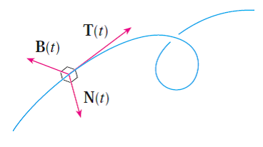
Desmos: https://desmos.com/3d/lucgz79gqg

13.4 Position, Velocity, Acceleration
If t = time and position is given by
$$r\left(t\right)= 〈x\left(t\right),y\left(t\right),z(t)〉$$
then
$$r^{'}\left(t\right)=\lim_{h→0}{\frac{r\left(t+h\right)-r\left(t\right)}{h}}=velocity$$
$\left|r^{'}(t)\right|=\frac{change in dist}{change in time}=speed=\frac{ds}{dt}$
$$r^{''}\left(t\right)=\lim_{h→0}{\frac{r^{'}\left(t+h\right)-r^{'}\left(t\right)}{h}}$$
$$=\frac{change in velocity}{change in time}=a\left(t\right)$$
Example
Let t be time in seconds and assume the position of an object (in feet) is given by
$$r(t) = ⟨50t, 6+50t-16t²⟩$$
Compute $r^{'}\left(t\right)$, ${|r}^{'}\left(t\right)|$, and $r^{''}\left(t\right)$.
Visual: https://desmos.com/calculator/7e3d6db11e

HUGE application: ANY motion problem
Newton’s 2nd Law of Motion states
$F=m·a$ , so $a=\frac{1}{m}·F$
- If $F=〈0,0,0〉$, then all the forces ‘balance out’ and there is no acceleration.
- If $F≠〈0,0,0〉$, then acceleration occurs and we integrate to find velocity and position.

HW Example
An object of mass 2 kg is being acted on by the force
$F=〈12t, 2e^{t},9e^{-3t}〉$.
You are given
$v(0)=〈0, -8,-3〉$ and $r(0)=〈1, 3,7〉$.
Find the position function.
What direction does the acceleration point?
$$a = aₜT + aₙN$$
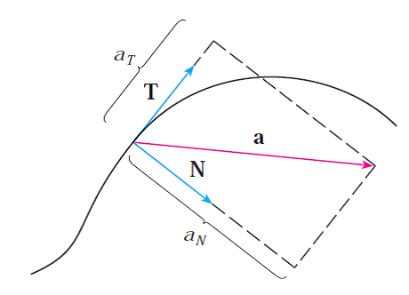
Tangential Component Facts
$${Def^{'}n: a}_{T}={comp}_{T}\left(a\right)=a∙T$$
$$Shortcut: { a}_{T}=\frac{r'∙r''}{{|r}^{'}|}$$
Interpretation: ${ a}_{T}=ν^{'}=\frac{d}{dt}\left|r^{'}\left(t\right)\right|$
$=$ “deriv. of speed”
$Note: a_{T}$ can be positive or negative (or zero)
positive – speedometer increasing
negative – speedometer decreasing

Normal Component Facts
$$Def^{'}n: a_{N}={comp}_{N}\left(a\right)=a∙N$$
$$Shortcut: { a}_{N} =\frac{|r^{'}×r^{''}|}{{|r}^{'}|}$$
Interpretation: ${ a}_{N}=kν^{2}$
$=$ curvature · (speed)²
Note: $a_{N}$ is always positive (or zero)
(accel. points “inward” relative to the curve, but not always “directly” inward)
Example
$$\overset{⃑}{r}\left(t\right)= <\cos\left(t\right),\sin\left(t\right),t>$$
Find the tangential and normal components of acceleration.

F’18 – Exam 2 – Loveless
Consider the position vector
$r\left(t\right)=〈5t,e^{t}, e^{-3t}〉$.
Find all values of t at which the tangential component of acceleration is zero.
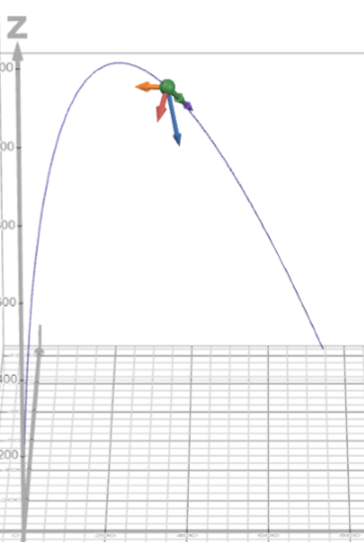
Two Fun Examples (that we will skip for time)
We throw a ball from the origin with an initial velocity parallel to the yz-plane. There are two forces, a force due to gravity and a force due to wind given by
$$F_{g} = ⟨0, 0, -mg⟩$$
$$F_{w} = ⟨mw, 0, 0⟩$$
Visual: https://desmos.com/3d/875cbc9d5a

Projectile Motion in 3D and fireworks
If we assume an object is accelerating in 3D due to gravity only (no air resistance or other forces), then we can model the motion by integrating the second derivative vector ⟨0, 0, −g⟩.
$$r(t) = r₀ + v₀t + ½⟨0, 0, -g⟩t²$$
where r₀ is the initial position and v₀ is the initial velocity.
$$v₀ = ⟨v₁, v₂, v₃⟩$$
$$x(t) = x₀ + v₁t$$
$$y(t) = y₀ + v₂t$$
$$z(t) = z₀ + v₃t - ½gt²$$
Visual: https://www.desmos.com/3d/qkrqow2wuu

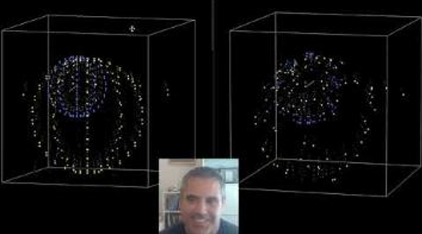

Derivation of a_{T} and a_{N} interpretations
(you can skip this)
Note visually that you can see:
$$a=a_{T}T+a_{N}N$$
We are trying to find the numbers in front of T and N.
Let $ν\left(t\right)=|\overset{⃑}{v}\left(t\right)|$ = speed.
$\overset{⃑}{T}\left(t\right)= \frac{\overset{⃑}{r}'(t)}{{|\overset{⃑}{r}}^{'}\left(t\right)|}=\frac{\overset{⃑}{v}(t)}{ν\left(t\right)}$ implies $\overset{⃑}{v}= ν\overset{⃑}{T}$.
$κ\left(t\right)= \frac{{|\overset{⃑}{T}}^{'}\left(t\right)|}{{|\overset{⃑}{r}}^{'}\left(t\right)|}=\frac{{|\overset{⃑}{T}}^{'}|}{ν\left(t\right)}$implies ${|\overset{⃑}{T}}^{'}|= κν$.
$\overset{⃑}{N}\left(t\right)= \frac{{\overset{⃑}{T}}^{'}(t)}{{|\overset{⃑}{T}}^{'}\left(t\right)|}=\frac{{\overset{⃑}{T}}^{'}}{κν}$ implies ${\overset{⃑}{T}}^{'}=κν\overset{⃑}{N}.$
Differentiating the first fact above gives
$\overset{⃑}{a}={\overset{⃑}{v}}^{'}= ν'\overset{⃑}{T}+ν\overset{⃑}{T}'$, so
$\overset{⃑}{a}={\overset{⃑}{v}}^{'}= ν'\overset{⃑}{T}+kν^{2}\overset{⃑}{N}$.

